Scientific Article
Centered title, Times New Roman, font size 18, line spacing 1.15, 15–25 words
First Name1 Last Name-Last Name¹, First Name2 Last Name-Last Name¹, First Name3 Last Name-Last Name^{2*}. Name of Institution, Department, Address, City, ZIP Code, State, and Country. ¹ Institute of Horticulture, Department of Plant Science, ² Agricultural Mycology, Department of Agricultural Parasitology, Universidad Autónoma Chapingo, Mexico-Texcoco Highway, Km. 38.5, Texcoco, Zip Code 56230, State of Mexico, Mexico.
NOTE: The format in which authors and co-authors list their first and last names will be respected, including the use of hyphens.
Do not modify the sidebar

*Corresponding author:
First Name Last Name-Last Name
nombre@correo.mx

Section:
Periodical edition / Special issue

Received:
00 XX, 202X
Accepted:
00 XX, 202X
Published:
00 XX, 202X

Citation:
Last Name-Last Name N, Last Name-Last Name N, Last Name-Last Name N, Last Name-Last Name N, and Last Name-Last Name N. 202X. Title of the article. Mexican Journal of Phytopathology XX(X): XX. https://doi.org/10.18781/R.MEX.FIT.0000-0

ABSTRACT Font size 11, line spacing 1.15, 300–400 words. Summarize each section of the document concisely. Ensure the inclusion of statistical data, variables, etc. The abstract should be self-explanatory; avoid using generic terms. Do not repeat the title in the abstract text; use scientific nomenclature and avoid abbreviations.
Background/Objective. Clearly and concisely define the importance of the study. Conclude the objective using an infinitive verb (20–25%). Trichoderma constitutes a viable alternative for reducing the destructive potential of soft rot (Sclerotium rolfsii) in potato crops. The objectives of this research were to determine the in vitro antagonistic effectiveness of Trichoderma asperellum, T. asperelloides, T. afroharzianum, and T. azevedoi against S. rolfsii (Scr4 and Scr17) and to determine the hyphal interactions of the antagonists, on addition to determinate the inhibition of mycelial growth of S. rolfsii (Scr4) by volatile metabolites produced by Trichoderma species.
Materials and Methods. Describe the most representative methods (isolation, identification, sequencing, study variables, experimental design, statistical analyses, etc.) (20–30%). The in vitro biological effectiveness of 16 T. asperellum isolates, five T. asperelloides isolates, four T. afroharzianum isolates, and one T. azevedoi isolate in inhibiting S. rolfsii (Scr4 and Scr17) mycelial growth was studied. The type of hyphal interaction between the same Trichoderma spp. isolates and S. rolfsii (Scr4) was also determined. The effect of volatile metabolites produced by Trichoderma spp. isolates on the inhibition of mycelial growth of S. rolfsii (Scr4) was evaluated. Data on mycelial growth inhibition were analyzed using nonparametric statistical analysis (Kruskal-Wallis), and the mean separation was performed using the procedures of Conover (1999) with (P ≤ 0.05).
Results. Present the data in accordance with the methodology, including hard data that are more representative, statistical significance, etc. (30–35%). In dual confrontations, Trichoderma species showed mycelial growth inhibitions of 21.0 to 75.4% and 23.6 to 77.1% in S. rolfsii isolates Scr4 and Scr17, respectively. Hyphal interactions of the same Trichoderma species consisted of vacuolization, granulation, coiling, adhesion, lysis, and penetration into the pathogen (Scr4); all four Trichoderma species inhibited mycelial growth (26.0 to 81.4%) of S. rolfsii. T. azevedoi stood out among the isolates for showing greater antagonistic capacity in all tests.
Conclusion. Present the most relevant conclusions in accordance with the objective(s) (10–15%). The results indicate that Trichoderma species, especially T. azevedoi (TAI73), inhibited the growth of S. rolfsii Scr4 (75.4%) and Scr17 (77.1%). T. azevedoi (TAI73) caused vacuolization, granulation, coiling, adhesion, and lysis of hyphae in the Scr4 isolate.
SOURCE: https://doi.org/10.18781/R.MEX.FIT.2024-10
Keywords: Include up to five simple, capitalized words. Avoid compound words and do not repeat words included in the title. Do not end the sentence with a period
TEMPLATE GUIDE
The template details the sections and general guidelines that must be followed in the Scientific Article document.
Maintain the margins of this template, a 1.0 cm indent on the first line of each paragraph, Times New Roman font, and 1.15-line spacing (including between paragraphs), except when a subtitle is included at the beginning of a paragraph; in this case, leave a single space. Maintain the font size and format used in this template.
IMPORTANT: Delete any text in blue, examples, links, or instructions when they are no longer needed. We recommend reviewing recent posts on the MJP website (www.rmf.smf.org.mx).
Introduction (First-level headings: Size 13, left-aligned, and bold)
This section should briefly describe the study and highlight why the research is important. Carefully outline the state of the art and cite relevant, pertinent, and recent publications. Ensure that the Introduction flows smoothly and is easy to understand. Finally, state the research hypothesis and objective(s). Keep in mind that there are different ways to cite sources in the text; choose the correct method and structure the reference format according to the type of source (click here). For more information, see the Author Guidelines.
Materials and Methods
Describe the methods and/or protocols that allow for the exact reproducibility of the experiment. New methodologies should be described in detail, while previously published methods may be summarized briefly and properly cited. Research papers reporting on large datasets in a publicly accessible repository must specify where they were deposited and provide the relevant access numbers, making them available prior to publication. Consider the specified units of measurement (click here). Second-level subheadings aligned to the left (no indentation), in bold, followed by a period.
Results and Discussion
The Results and Discussion may be presented in the same section or separately. Present the results of the experimental data obtained clearly, objectively, and precisely, with a general interpretation in accordance with the order presented in Materials and Methods. Use tables and/or figures; tables should not be repeated verbatim in the body of the document. Interpret your results by comparing them with previous research or similar studies and contrasting them with the hypothesis(es). Use relevant references and current to discuss the results in depth. Include logical deductions; avoid unsubstantiated speculation. Additionally, you may add suggestions for future studies. Second-level subheadings should be left-aligned (no indentation), in bold, and followed by a period.
Figures
They must be cited in the main text as Figure 1, Figure 2, etc. Figures or diagrams must be inserted after they are cited in the text. Use high-quality images with a resolution of at least 300 DPI or proportional to the page size. To compare symptoms, isolates, or treatments, please combine individual images into a single composite image, which must be submitted in an editable format (ungrouped) with a resolution of 600 DPI:
• Panel Identification: Label each quadrant of the composition with bold capital letters (A, B, C, D) in the upper-right corner. Use 12-pt Arial or Helvetica font.
• Visual Layout: The background borders between panels should be minimal (2^{1/4}pt), white, and perfectly aligned. Avoid unnecessary empty spaces.
• Scale Bars: It is mandatory to include microscopic or macroscopic scale bars printed directly on each relevant image. Indicate the length of the scale bar in the figure caption (e.g., “Scale bar = 10 μm”), avoiding the use of relative magnifications (such as “100x”) that change when the image size is altered.
• Focus Annotations: Use high-contrast arrows (black with a white outline, or vice versa) to highlight specific pathogen structures or symptoms, taking care not to clutter the image. For more information, see the Authors’ Guide.
Figure Example:
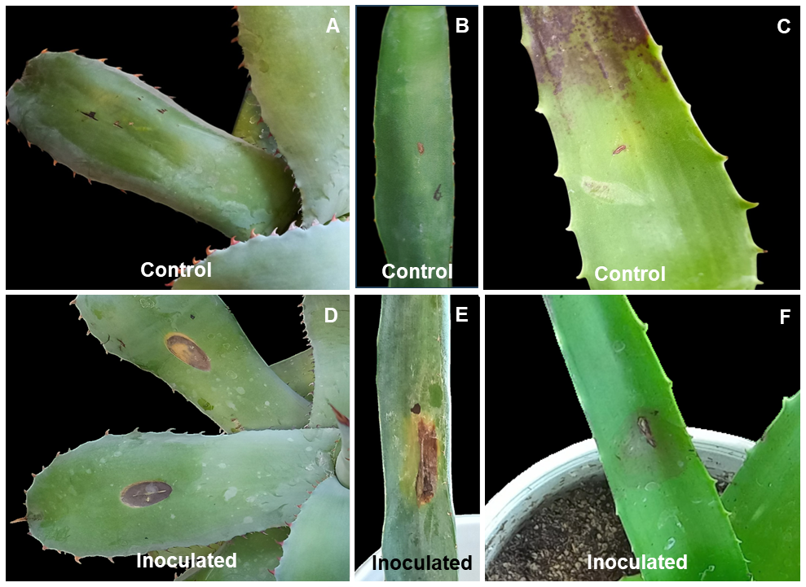

SOURCE: https://doi.org/10.18781/R.MEX.FIT.2512-3
Figure 1. The caption should be self-explanatory. The reader should be able to understand the purpose of the figure without referring to the main text of the document. Specify the host, the pathogen (genus and species in italics), the variables plotted, the meaning of each letter in multiple panels (e.g., “A: Field leaf symptoms. B) Monospore isolation of X on PDA.") and a description of any arrows or scale bars present. Font: Times New Roman, size 9, line spacing 1.15.
Tables
Tables must be cited in the main text as Table 1, Table 2, etc., and must be created in Word, not Excel. They must contain three main lines: two separating the titles and a closing line. Write captions in lowercase letters. Footnotes for tables must be identified with lowercase letters (from the end of the alphabet) in superscript (in sequence: ^{x}, ^{y}, ^{z}). To indicate levels of statistical significance, use asterisks (* = p ≤ 0.05, ** = p ≤ 0.01). For numbers, use only one decimal place, separated by a period; for example, 3.2%, 5.7 cm, etc.
Example of a Table:
Table1 . The title should provide clear and precise information; the information in the table should be understandable without referring to the text. Text: Times New Roman, size 9. Justified and at the beginning of the table.
JJR198 inoculum density  (CFU mL⁻¹) | No. of sporangia/VA* |  | No. of zoospores  (1.0 × 10³ mL⁻¹)
JJR198 inoculum density  (CFU mL⁻¹) | PcAR-2 | Pc57 | Pc57
SDW¤ (control)  1.0 × 10⁴  1.0 × 10⁶  1.0 × 10⁸ | 60.1 ± 6.2 a  41.0 ± 4.9 a  50.1 ± 10.7 a  0.0 ± 0.0 b | 234.2 ± 12.7 a  207.2 ± 15.3 a  205.5 ± 31.4 a  0.0 ± 0.0 b | 25.9 ± 4.9 a  26.1 ± 2.6 a  20.6 ± 3.3 a  0.2 ± 0.1 b
*VA, viewing area of 2 mm² under light microscope. ¤SDW, sterile distilled water. Results are means ± standard errors of four replications. Same letters in each column denote no significant difference (Tukey, p ≤ 0.05).
SOURCE: https://doi.org/10.18781/R.MEX.FIT.2511-2
Conclusions
The conclusions should directly address the objective(s) stated in the introduction, summarizing the main contribution and scientific advancement resulting from your research. Present representative values of the results, such as means, ranges, proportions, percentages, etc. Include statistical significance associated with factors and/or treatments in the case of experimental designs.
Limitations. Briefly indicate the methodological limitations that could be improved in similar studies, such as sample size, Koch’s postulates, number of replicates, among others. Also, indicate aspects that have been poorly studied, investigated, or for which conclusions are partial or inconclusive.
Conflict of Interest. If there are no conflicts of interest, the authors must explicitly state this using the following text: “The authors declare that they have no conflict of interest regarding the research, authorship, and/or publication of this article.”
Funding. List sources of funding (if applicable), which may include grants, institutional funds, in-kind support from companies, etc.
Acknowledgments. Express any acknowledgments deemed appropriate; these may include cooperating producers, groups, or associations, as well as researchers who reviewed or contributed to the document, among others.
Authors’ Contributions. Briefly indicate the role(s) of each author who contributed to the development of the research, with regard to the conception of the study, experimental design, data analysis, statistics, review, etc.
Supplementary Material. In this section, indicate, if necessary, any attached documents that support a process within the research project; these attachments should be in .doc, .xlsx, or similar formats.
References
It is the authors’ responsibility to verify that citations in the text correspond to the reference list and vice versa. Cite 30–40 current references. Use a 0.5 cm indent, arrange them alphabetically, use 9-point font, and single-space the text.
All references must strictly adhere to the RMF/MJP style. Use the Author and Year system. In the body of the document, punctuation depends on the sentence’s position in the narrative: one author, Pfender (2010) or (Pfender, 2010); two authors, Leyva-Mir and García-Velasco (2022) or (Leyva-Mir and García-Velasco, 2022); more than two authors, Santos-Cervantes et al. (2020) or (Santos-Cervantes et al., 2020). Multiple citations should be listed in chronological order and separated by semicolons: (Villanueva-Arce, 2015; Ayala-Escobar and Yáñez-Morales, 2018; Santos-Cervantes et al., 2020). For the same author and year, insert a consecutive lowercase letter after the year: (Pérez, 2020a; Pérez, 2020b).
All articles must include a DOI hyperlink or web link. Use “et al.” starting with the sixth author and write the full journal name in regular text (without italics). The document will be returned to the author if it does not comply with the guidelines (for more information, see the Authors’ Guide).
Examples of citations according to publication type:
Structure of a Scientific Article. Ortega-Acosta SA, Velasco-Cruz C, Hernández-Morales J, Ochoa-Martínez DL and Hernández-Ruiz J. 2016. Diagrammatic logarithmic scales for assess the severity of spotted leaves and calyces of roselle. Mexican Journal of Phytopathology 34: 270-285. https://doi.org/10.18781/R.MEX.FIT.1606-6
Book Structure. Anaya-Lang AL, Yáñez-Morales M y Gómez-Rodríguez O. 2016. Patología de semillas forestales en México. 2a Edición. Editorial Colegio de Postgraduados. Texcoco, Estado de México, México. 312 p.
Book Chapter Structure. Cano-Madrigal J y Pérez-Brito D. 2021. Diagnóstico serológico y molecular de virus fitopatógenos en cultivos tropicales. In: Silva-Rojas HV, Martínez-Espinoza AD (Eds.). Herramientas Biotecnológicas aplicadas a la Sanidad Vegetal en México. Colegio de Postgraduados. Texcoco, Estado de México, México. pp. 112-135.
Website structure: Servicio Nacional de Sanidad, Inocuidad y Calidad Agroalimentaria (SENASICA). 2024. Ficha técnica de vigilancia epidemiológica para Ralstonia solanacearum raza 3 en el territorio mexicano. Disponible en línea en: www.gob.mx. (Consulta: marzo 15, 2026).
Nomenclature and Abbreviations
1. Fertilizers. Describe fertilizer doses in elemental terms (e.g., N, P, K, etc.). If necessary, indicate the source of the fertilizer.
2. Pesticides. Use the technical name (active ingredient) and concentration of the pesticides; the trade name may be included in parentheses. Documents on agrochemical management will be considered provided their content contributes new technical and scientific knowledge.
3. Measurements. Based on the International System of Units (SI). Symbols should not be followed by a period, unless it is the end of a sentence. Maintain the same format for units of measurement throughout the document. Commonly used measurements are listed in the following table:
Quantity | Unit | Symbol
Length | Kilometer | km
Length | Meter | m
Length | Centimeter | cm
Length | Millimeter | mm
Length | Micrometer | μm
Length | Nanometer | nm
Mass | Gram | g
Mass | Milligram | mg
Mass | Kilograms per hectare | kg ha⁻¹
Mass | Kilogram | kg
Mass | Metric ton | t
Time | Hour | h
Time | Minute | min
Time | Second | s
Temperature | Degrees Celsius | °C
Area | Hectare | ha
Volume | Liter | L
Volume | Milliliter | mL

