Phytopathological Report
Centered title, Times New Roman, font size 18, line spacing 1.15, 15–25 words
First Name1 Last Name-Last Name¹, First Name2 Last Name-Last Name¹, First Name3 Last Name-Last Name^{2*}. Name of Institution, Department, Address, City, ZIP Code, State, and Country. ¹ Institute of Horticulture, Department of Plant Science, ² Agricultural Mycology, Department of Agricultural Parasitology, Universidad Autónoma Chapingo, Mexico-Texcoco Highway, Km. 38.5, Texcoco, Zip Code 56230, State of Mexico, Mexico.
NOTE: The format in which authors and co-authors list their first and last names will be respected, including the use of hyphens.
Do not modify the sidebar

*Corresponding author:
First Name Last Name-Last Name
nombre@correo.mx

Section:
Periodical edition / Special issue

Received:
00 XX, 202X
Accepted:
00 XX, 202X
Published:
00 XX, 202X

Citation:
Last Name-Last Name N, Last Name-Last Name N, Last Name-Last Name N, Last Name-Last Name N, and Last Name-Last Name N. 202X. Title of the article. Mexican Journal of Phytopathology XX(X): XX. https://doi.org/10.18781/R.MEX.FIT.0000-0

ABSTRACT Font size 11, line spacing 1.15, 200–300 words. Provide a concise summary of each section of the document. Ensure the inclusion of statistical data, variables, etc. The abstract should be self-explanatory; avoid the use of generic terms. Do not repeat the title in the text of the abstract; use scientific nomenclature and avoid abbreviations.
Background/Objective. Clearly and concisely define the importance of the study. Conclude the objective using an infinitive verb (20–25%). In November 2020, in two bean (Phaseolus vulgaris) plantations in northern Sinaloa, symptoms of root rot and plant dieback were observed, with an incidence of up to 35% per plot. The present study was established with the aim of identifying, through the sequencing of ITS and RPB2, the pathogens associated with root rot in beans.
Experimental development. Describe the most representative methods (isolations, identification, sequencing, study variables, experimental design, statistical analyses, etc.) (20–30%). Plants with symptoms were selected from bean crops in Ahome, Sinaloa, Mexico. Samples of the lesion advances of the roots of the plants were taken, and fungi with typical morphological characteristics of Rhizoctonia spp. were isolated, which presented septate, hyaline mycelium, forming a right angle and constriction of the basal cell, did not produce spores, and formed sclerotia. Koch's postulates were performed in pots, the inoculum was placed alongside the seed at the time of planting to evaluate the effect on germination and severity in seedlings. Once its pathogenicity was demonstrated, the isolates FAVF397 and FAVF398 were identified molecularly.
Results. Present the data in accordance with the methodology, using hard data that is more representative, statistical significance, etc. (30–35%). The isolates FAVF397 and FAVF398 were molecularly identified as Rhizoctonia solani AG-7 and are responsible for the root rot of common bean.
Conclusion. Present the most relevant conclusions in accordance with the objective(s) (10–15%). The AG7 anastomosis group is reported for the first time in beans in Sinaloa. These findings represent a scientific contribution for the benefit of producers of this crop by allowing the design of relevant and effective management strategies.
SOURCE: https://doi.org/10.18781/R.ME X.FIT.2409-1
Keywords: Include up to five simple, capitalized words. Avoid compound words and do not repeat words included in the title. Do not end the sentence with a period

TEMPLATE GUIDE
The template outlines the sections and general guidelines to be used in the Phytopathological Report document.
Maintain the margins of this template, with a 1.0 cm indent on the first line of each paragraph, Times New Roman font, and 1.15-line spacing (including between paragraphs), except when a subtitle is included at the beginning of a paragraph; in this case, leave a single space. Maintain the font size and format used in this template. Do not exceed 3,000 words, including one table or figure.
IMPORTANT: Remove any text in blue, examples, links, or instructions when they are no longer required. We recommend reviewing recent publications on the MJP website (www.rmf.smf.org.mx).
Introduction (First-level subheadings: Size 13, left-aligned, and bold)
This section should briefly describe the study and highlight why the research is important. Carefully outline the state of the art and cite relevant, recent publications. Ensure that the Introduction flows smoothly and is easy to understand. Finally, state the hypothesis and/or objective(s) of the research. Keep in mind that there are different ways to cite sources in the text; choose the correct method and structure the reference format according to the type of source (click here).
Experimental development
The Phytopathological Report presents information on epidemiological outbreaks, significant changes in the regional distribution of pathogens, new hosts, and/or detections of phytopathogens at the species or intraspecific level, resistance of phytopathogens to chemical/biological products, as well as the release of resistant varieties. The text should flow smoothly and without separate sections. To maintain sequence and order, use subheadings embedded within paragraphs that refer to the methodology used, results, and discussion (see examples). Use the specified units of measurement (click here). Second-level subheadings should be left-aligned (no indentation), in bold, and followed by a period.
Figures
They must be cited in the main text as Figure 1, Figure 2, etc. Figures or diagrams must be inserted after they are cited in the text. Use high-quality images with a resolution of at least 300 dpi or proportional to the page size. Figure compositions must be submitted in an editable format (ungrouped). To compare symptoms, isolates, or treatments, please combine the individual images into a single composite figure:
• Panel Identification: Label each quadrant of the composite with bold uppercase letters (A, B, C, D) in the upper-right corner. Use 12-point Arial or Helvetica font.
• Visual Layout: The background borders between panels should be minimal (2^{1/4} pt), white, and perfectly aligned. Avoid unnecessary empty spaces.
• Scale Bars: It is mandatory to include microscopic or macroscopic scale bars printed directly on each relevant image. Indicate the length of the scale bar in the figure caption (e.g., “Scale bar = 10 μm”), avoiding the use of relative magnifications (such as “100x”) that change when the image size is altered.
• Highlighting Tips: Use high-contrast arrows (black with a white outline, or vice versa) to point out specific pathogen structures or symptoms, taking care not to clutter the image. For more information, see the Authors’ Guide.
Figure Example:
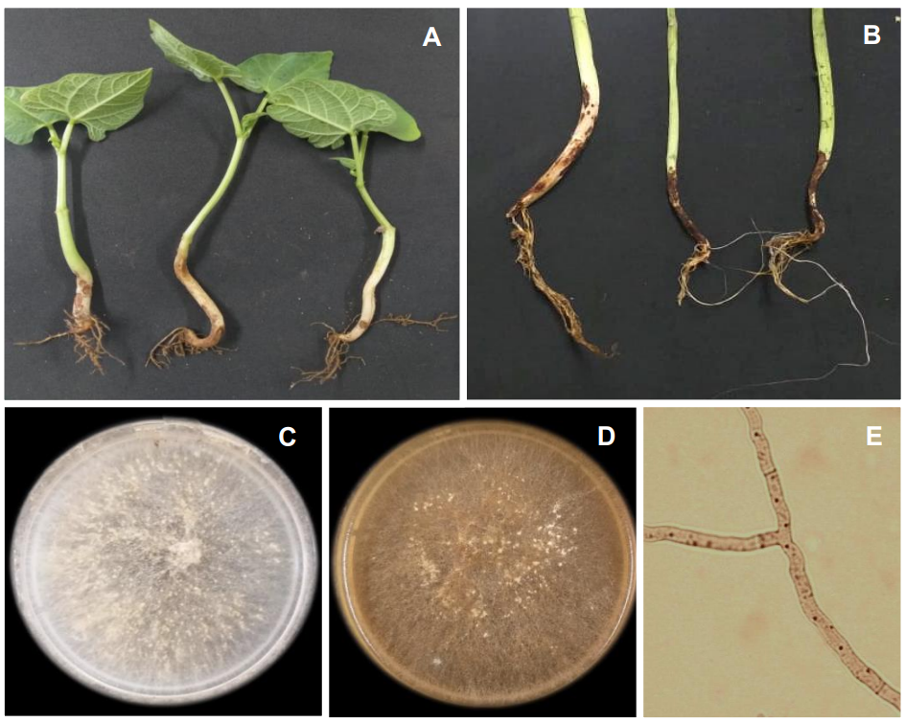

SOURCE: https://doi.org/10.18781/R.MEX.FIT.2409-1
Figure 1. The caption should be self-explanatory. The reader should be able to understand the purpose of the figure without referring to the main text of the document. Specify the host, the pathogen (genus and species in italics), the variables plotted, the meaning of each letter in multiple panels (e.g., “A: Field leaf symptoms. B) Monospore isolation of X on PDA.") and a description of any arrows or scale bars present. Font: Times New Roman, size 9, line spacing 1.15.
Tables
Tables must be cited in the main text as Table 1, Table 2, etc., and must be created in Word, not Excel. They must contain three main lines: two separating the titles and a closing line. Write captions in lowercase letters. Footnotes for tables must be identified with lowercase letters (from the end of the alphabet) in superscript (in sequence: ^{x}, ^{y}, ^{z}). To indicate levels of statistical significance, use asterisks (* = p ≤ 0.05, ** = p ≤ 0.01). For numbers, use only one decimal place, separated by a period; for example, 3.2%, 5.7 cm, etc.
Example of a Table:
Table1 . The title should provide clear and precise information; the information in the table should be understandable without referring to the text. Text: Times New Roman, size 9. Justified and at the beginning of the table.
Region | ELISA  (positive/ n tested) |  | TEM  (positive/ n tested) |  | RT-PCR  (positive/ n tested)
Region | S | A | S | A | S ^{z} | A
North | 0/35 | 0/4 | 4/4 | -- | 60/61 | 0/28
Atlantic, Guapiles | 0/18 | 0/3 | 2/2 | -- | 48/50 | 1/18
Atlantic, Guacimo | 0/17 | 0/3 | 2/2 | -- | 42/47 | 0/21
Central Valley | -- | -- | -- | 0/1 | -- | 0/2
Total | 0/70 | 0/10 | 8/8 | 0/1 | 150/158 | 1/69

S or A= Samples from symptomatic (S) or asymptomatic (A) plants; ELISA: tests carried out to: Potyvirus papayanuli, Potexvirus papayae, Orthotospovirus tomatomaculae, Cucumovirus CMV, and Potyvirus group; TEM: presence of bullet-shaped particles into the nuclei; RT-PCR: amplicon of 900 bp obtained; ^{z}: samples tested included the 32 (8 and 24) symptomatic plants collected to validation tests using primers Rhab-R /Rhab-F; --: Not tested

SOURCE: https://doi.org/10.18781/R.MEX.FIT.2602-3

Conclusions
These should directly address the objective(s) stated in the introduction, summarizing the main contribution and scientific advancement achieved by your research. Present representative values of the results, such as means, ranges, proportions, percentages, etc. Include statistical significance associated with factors and/or treatments in the case of experimental designs
Limitations. Briefly indicate the methodological limitations that could be improved in similar studies, such as sample size, Koch’s postulates, number of replicates, among others. Also, indicate aspects that have been poorly studied, investigated, or for which conclusions are partial or inconclusive.
Conflict of Interest. If there are no conflicts of interest, the authors must explicitly state this using the following text: “The authors declare that they have no conflict of interest regarding the research, authorship, and/or publication of this article.”
Funding. Mention the source(s) of funding (if applicable), which may include grants, institutional funds, in-kind support from companies, etc.
Acknowledgments. Express any acknowledgments you deem appropriate; these may include cooperating producers, groups or associations, and researchers who reviewed or contributed to the document, among others.
Authors’ Contributions. Briefly indicate the role(s) of each author who contributed to the development of the research, with regard to the conception of the study, experimental design, data analysis, statistics, review, etc.
References
It is the authors’ responsibility to verify that citations in the text correspond to the reference list and vice versa. Cite 05-10 current references. Use a 0.5 cm indent, arrange them alphabetically, use 9-point font, and single-space the text.
All references must strictly adhere to the RMF/MJP style. Use the Author and Year system. In the body of the document, punctuation depends on the sentence’s position in the narrative: one author, Pfender (2010) or (Pfender, 2010); two authors, Leyva-Mir and García-Velasco (2022) or (Leyva-Mir and García-Velasco, 2022); more than two authors, Santos-Cervantes et al. (2020) or (Santos-Cervantes et al., 2020). Multiple citations should be listed in chronological order and separated by semicolons: (Villanueva-Arce, 2015; Ayala-Escobar and Yáñez-Morales, 2018; Santos-Cervantes et al., 2020). For the same author and year, insert a consecutive lowercase letter after the year: (Pérez, 2020a; Pérez, 2020b).
All articles must include a DOI hyperlink or web link. Use “et al.” starting with the sixth author and write the full journal name in regular text (without italics). The document will be returned to the author if it does not comply with the guidelines (for more information, see the Authors’ Guide).
Examples of citations according to publication type:
Structure of a Scientific Article. Ortega-Acosta SA, Velasco-Cruz C, Hernández-Morales J, Ochoa-Martínez DL and Hernández-Ruiz J. 2016. Diagrammatic logarithmic scales for assess the severity of spotted leaves and calyces of roselle. Mexican Journal of Phytopathology 34: 270-285. https://doi.org/10.18781/R.MEX.FIT.1606-6
Book Structure. Anaya-Lang AL, Yáñez-Morales M y Gómez-Rodríguez O. 2016. Patología de semillas forestales en México. 2a Edición. Editorial Colegio de Postgraduados. Texcoco, Estado de México, México. 312 p.
Book Chapter Structure. Cano-Madrigal J y Pérez-Brito D. 2021. Diagnóstico serológico y molecular de virus fitopatógenos en cultivos tropicales. In: Silva-Rojas HV, Martínez-Espinoza AD (Eds.). Herramientas Biotecnológicas aplicadas a la Sanidad Vegetal en México. Colegio de Postgraduados. Texcoco, Estado de México, México. pp. 112-135.
Website structure: Servicio Nacional de Sanidad, Inocuidad y Calidad Agroalimentaria (SENASICA). 2024. Ficha técnica de vigilancia epidemiológica para Ralstonia solanacearum raza 3 en el territorio mexicano. Disponible en línea en: www.gob.mx. (Consulta: marzo 15, 2026).
Nomenclature and Abbreviations
1. Fertilizers. Describe fertilizer doses in elemental terms (e.g., N, P, K, etc.). If necessary, indicate the source of the fertilizer.
2. Pesticides. Use the technical name (active ingredient) and concentration of the pesticides; the trade name may be included in parentheses. Documents on agrochemical management will be considered provided their content contributes new technical and scientific knowledge.
3. Measurements. Based on the International System of Units (SI). Symbols should not be followed by a period, unless it is the end of a sentence. Maintain the same format for units of measurement throughout the document. Commonly used measurements are listed in the following table:
Quantity | Unit | Symbol
Length | Kilometer | km
Length | Meter | m
Length | Centimeter | cm
Length | Millimeter | mm
Length | Micrometer | μm
Length | Nanometer | nm
Mass | Gram | g
Mass | Milligram | mg
Mass | Kilograms per hectare | kg ha⁻¹
Mass | Kilogram | kg
Mass | Metric ton | t
Time | Hour | h
Time | Minute | min
Time | Second | s
Temperature | Degrees Celsius | °C
Area | Hectare | ha
Volume | Liter | L
Volume | Milliliter | mL

Examples:

Sampling of hibiscus calyxes. Fifteen hibiscus calyxes with blight and 15 asymptomatic calyxes (Figure 1) were collected from each of the three varieties: “Criolla de Guerrero,” “China Negra,” and “Sudán” in the towns of San Miguel (N 16°59'15.4“, W 99°05'56.0”) and San José La Hacienda (N 16°58'30.7“, W 99°03'29.1”), both located in the municipality of Ayutla, as well as in Tecuantepec (N 16°59'58.9“, W 99°15'10.4”) and Saucitos (N 16°59'14.0“, W 99°18'16.8”) in the municipality of Tecoanapa.
---

Morphological and molecular identification. Ten colonies were obtained; these grew rapidly on PDA medium, had a cottony consistency, and were bright orange in the center and lighter at the edges (Figure 2A–B). They produced abundant macroconidia with 3–5 septa, ranging from straight to slightly curved, measuring 47.8–10. 3 x 4.6–2.4 µm (length x width), with the presence of monophyalidia, macroconidia with a foot-shaped basal cell (Figure 2 C–E), as well as chlamydospores in chains (Figure 2 F–G). The morphological characteristics observed were consistent with Fusarium sp.

